|  |
| --- |
|  |
| *Valle del Lili Foundation*  Team #1 |
| |  |  |  | | --- | --- | --- | | Raymond Delgado, William Lam, Taron Sarksyan | 4/5/21 | CIS 5900 | Dr. Howell | |  |  |  | |  |  |  | |  |  |  | |

**Table of Contents**

Executive Summary 2

Introduction 2

Problem 2

Solution 3

Target Market 4

Team Roles 4

Financial Summary (ROI) 5

Storyboard 6

(GUI – Graphical User Interface) 6

System Components 6

Requirements Survey 7

User Stories 8

Use Case Diagram 9

Domain Model Class Diagram 10

State Machine Diagram 13

Fully Developed Use Case Descriptions 14

Activity Diagram 17

System Sequence Diagram (SSD) 18

CRUD (Bonus) 19

Design Class Diagram (DCD) 20

Sequence Diagram with View and Data Access Layers 22

Package Diagram 23

Conclusion 24

References 24

## Executive Summary

W.I.P – Will do when case is finished.

## Introduction

The Valle del Lili Foundation is a private non-profit organization founded in 1982, in which the hospital started in tertiary medical care. VLF was ranked third best hospital in Latin America and best in Colombia due to their strong belief in their culture of quality and continuous improvement. The turning point was when VLF made the ambitious decision to go from paper format to EMR (Electronic Medical Records) to resolve issues relating to the inefficiencies and inconsistencies happening with the process flow of patients. This ultimately led to the implementation of SAP, which was a challenging collaborative atmosphere with medical staff and the organization as a whole.

### Problem

Problems prior to SAP include incoherent coordination between medical staff, handwritten forms (with delayed transition to other medical staff), and multiple forms to be completed independently from one another, which caused inconsistencies and incomplete requests; for example, one form out of the required forms in a patient’s chart could go missing. One major issue was specific medical staff requiring the patient’s chart at the same time. Since it was not available, this would cause delay of the entire workflow process for the patient. Requiring the patient’s medical record on demand was definitely a necessity. The amount of forms required at a time would generally cause confusion; time wasted, and cause extra workload, which decreased inpatient room turnover. Paper records was a cause of concern because not only was the amount of records increasing, but the need to physical storage capacity as well. The most concerning issue heavily connects to the examples listed above is the issue of data loss.

Furthermore, VLF’s billing to HPO (insurers) were effected, because of the enormous amount of billing items. Since it was paper at this point, tracking them manually would cause delay. If there is delay in any part of the process, there is a delay in payment. A financial position VLF would not like to be in. Even with SAP implemented already, there could be risk of data loss due to technical illiterate medical staff on the field. Furthermore, mistakes is a possibility from trained staff.

### Solution

It is a known fact that the SAP implementation for VLF was successful overtime. There is always areas of opportunity for the process considering some issues could’ve been ongoing such as the inefficiencies (doctors struggling to input patient data onto SAP) in addition to the reluctance of doctors not wanting to adapt to the new system and delays in the process overall.

For this specific process to become more efficient and more hands on to medical staff (doctors in particular), we propose building an app to prevent data loss by offering an additional means to collect data that works coherently with the current SAP system. It will be able to scan and accurately read unstructured data. After passing an integrity test, it would convert the data into structured data, which will then be enter into the SAP system. The unstructured data consists of an image of handwritten notes or whiteboard. Medical staff would just have to take a picture with their mobile device and have the system will process through (see Figure # State Machine Diagram on page X). Additionally, patients will have limited access to the system to upload their own notes/requests to the hospital, even from the comfort of their own home.

An audit trail from the system will also created to keep track of active users and each of their created, viewed and modified images that are uploaded to the SAP system. The app would require scheduled maintenance routinely to ensure reliability, data integrity, and performance. VLF may be able to outsource a technician to keep the app up-to-date.

According to the case, doctors were having issues inputting data onto the SAP system. We firmly believe that handwriting notes whether on a whiteboard or on paper is traditional and necessary in practice. Not to mention that there are technical illiterate individuals in society. Our solution is an additional means to collect data for those who need it to prevent data loss further. This will ultimately cause less delay and inefficiencies at the workplace, and less stringent issues with HPO (insurers) to receive payment from billing since all the data necessary is sent with no delay due to our simplified method to capture unstructured (handwritten) data to EMR.

## Target Market

This is a list of people and groups who participated in the survey in the categories of stakeholders (Including sponsors as well.). Health Promotion Organizations (HPO), Care Delivery Organizations (CDO) and Patients are the External Stakeholders that were not involved in the survey.

* Executive Stakeholders: CEO (Vicente Borrero), CMD (Marcela Granados), Chief Nursing Officer (Betty Gomez), Heads of the Medical Units (Ex. Maria del Carmen Valencia – Chief OR Nurse)
* Internal Stakeholders: Physicians (Doctors, Surgeons), Medical Equipment Preparers, Nurses, Anesthesiologists, Medical Assistants, Operating Room Staff, Clerical Staff, IT Team (Head of IT, IT Help Desk).

## Team Roles

Team member roles. What talent do you need to make the project successful?

|  |  |  |  |
| --- | --- | --- | --- |
| **Name and Signature** | **Role** | **Position** | **Contact Information** |
| John Doe | Executive Sponsor | CIO | 323-555-5550 |
| Jane Doe | Executive Sponsor | CFO | 323-555-5551 |
|  | Project Manager | Manager | 323-555-5552 |
|  | Developer |  |  |
|  |  |  |  |

## Financial Summary (ROI)

|  |  |  |  |  |  |  |
| --- | --- | --- | --- | --- | --- | --- |
|  | **0 (Intial Investment)** | **Cost Savings Yr 1** | **Yr 2** | **Yr 3** | **Yr 4** | **Yr 5** |
| Mobile App | -$10,000.00 | $2,000.00 | $2,800.00 | $4,000.00 | $4,770.00 | $6,000.00 |
| Annual Maintenance |  | ($500) | ($525) | ($575) | ($600) | ($625) |
| Total |  | $1,500.00 | $2,275.00 | $3,425.00 | $4,170.00 | $5,375.00 |

|  |  |
| --- | --- |
| Discount Rate | 0% |
| PV of Cash Flow | **$16,745.00** |
| NPV | **$6,745.00** |
| IRR % | **22.37%** |
| ROI % | **67.45%** |

The financing for the Mobile App will consist in forming a team, design, research and development, and prototype. We have estimated the initial cost to be $10,000.00 total. However, since the mobile app does not really produce cash flow, we have determined the impact it will cause towards cost savings annually for the next five years due to less data loss occurring on the floor. Data loss may cause fluctuation of unnecessary spending and opportunities lost such as improper payment from HPO due to missing documentation given. An assumption we have is that as time progresses, medical staff will become more acquainted with the app. This will result in more usage, standardization, and less data loss. To reflect that, the hospital will save more money annually.

Present value of money saved due to prevention of data loss is $16,745.00 within the next 5 years as mentioned. The app however will require annual maintenance for updates, reliability/stability, and to uphold data integrity. The net present value in turn is $6,745.00 (-$10,000.00 + $16,745.00). The discount rate is 0% because the hospital does not require borrowing money. The internal rate of return is 22%, which is acceptable given that 0%. ROI is 67.45% given that $6,745.00 is earned back from the $10,000 initial investment after 5 years.

### Storyboard

## (GUI – Graphical User Interface)

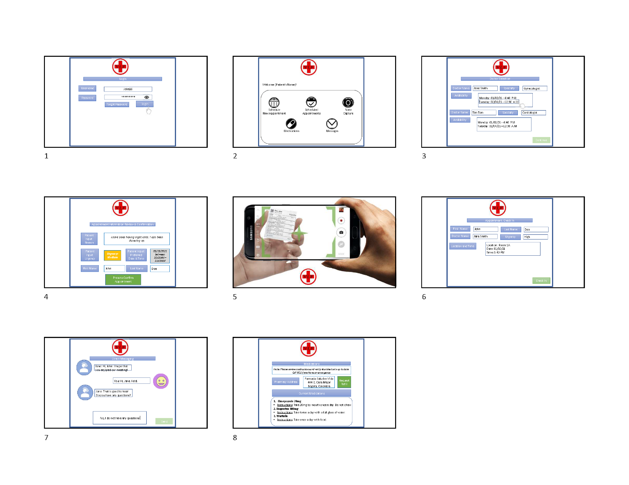

### System Components

1) Log in for Patient Screen:

•Fill the fields: Name and Password - Click Log In. Explain that the account was given to the patient by an administrator at the hospital/clinic

2) Main menu - Buttons (screens) (1)Schedule a New Appointment, (2)Scheduled Appointments, (3)Note Capture, (4)Messages, (5)Medications

3) Schedule New Appointment Screen:

•Fields: Name, D.O.B, Meeting Reason, urgency level (3 levels low/medium/high), Preferred Date/Time

Click Next (for Next Window)

3.1) Schedule a New Appointment (continued) Screen:

•List of Available Doctors with a sub-section showing their specialty

•Date and time of availablity (may or may not be 100% the same as the patient requested)

Click Next (for Next Window)

3.2) Schedule a New Appointment (continued) Screen:

•Confirm Appointment with all the details

4) Scheduled Appointments Screen:

•Table showing the scheduled appointment: Patient name, D.O.B, Date/Time, Reason, Urgency level, Doctor's name, hospital/clinic location

•Check-In button

•*Optional* Show past appointments history

5) Note Capture Screen:

•Show a button to activate the phone's camera, and a brief description on how to use it

6) Messages Screen:

•Relevant messages to the patient from the hospital/clinic admin. clerk (i.e appointment reminders), private messages from the doctor, private messages from the nurse

7) Medications Screen:

•List of verified prescribed medications from the Doctor

•Doctor's name

•Pharmacy address

•Instructions on how to use medication

•Request refills button

STORYBOARD:<https://csula-my.sharepoint.com/:p:/r/personal/tsarksy_calstatela_edu/Documents/Microsoft%20Teams%20Chat%20Files/VLF%20Storyboard.pptx?d=w2f2a390eef60404889bbc1fb152f60de&csf=1&web=1&e=0u3YIu>

SURVEY: <https://calstatela.co1.qualtrics.com/jfe/form/SV_5tCkgZSdLthSvzg>

## Requirements Survey

This survey was given to the Internal and Executive Stakeholders. Names were needed from those who completed it because some questions may not be related to a specific department. This survey was highly needed because not every staff member was interviewed. A disclaimer of the Proposed Solution was shown for a better understanding before taking the survey as well.

1. After understanding the proposed solution, does VLF need an app to turn unstructured data to structured data by mobile capture? (**Yes/No)**
2. Were you working for VLF before the SAP implementation? (**Yes/No)**
3. Do you still leave notes on paper? (**Yes/No**)
   1. What do you usually write on the notes? (**Written Response if Yes is Selected**)
4. When receiving notes from another staff member, are the notes legible enough to understand? (**Yes/No**)
5. Do you use a whiteboard? (**Yes/No**)
   1. If so, how often do you write on the whiteboard? (**If Yes is Selected**) (**Rarely, Occasionally, Frequently**)
   2. What type of information do you write on the Whiteboard? (**Written Response if Yes is Selected**)
6. How often do you communicate with different departments? (**Rarely, Occasionally, Frequently**)
7. What Operating System do you use on your phone? (**iOS, Android**)
8. How often do patients send or give paper documents/notes to the staff at VLF? (**Rarely, Occasionally, Frequently**)
9. Do you write prescriptions on RX sheets? (**Yes/No**)
   1. What do you write on the RX sheets? (**Written Response if Yes is Selected**)
10. Does the app need video conferencing with patients for a better understanding of their notes and documents? (**Yes/No**)
11. The proposed solution of converting text that is written on paper to data files will prevent data loss for the hospital. (**1 – Not at All Likely, 5 – Neutral, 10 – Extremely Likely**)
12. Any additional comments? (**Written Response**)

## User Stories

Based on the requirement survey results and meeting with project sponsors and system users, we have identified three users. The main actors of the system are the doctors, patients, and nurses. The core features of the system are:

* Being able to recognize image and text.
* Provide an audit trail
  + Keep track of who make changes
  + When changes occur

Figure 01: Three user stories with acceptance criteria.

|  |
| --- |
| **User Story:** As a **patient**, I want to **share** how I feel with my **doctor** and **nurse**.  **Acceptance Criteria:**   1. System must be able to read users' writing. 2. Must organize patient's thoughts. 3. Must quickly share patient's notes with doctor and nursing staff. |

|  |
| --- |
| **User Story:** As a **doctor**, I want to **choose** how I want to **input** the **health record** into the **system**.  **Acceptance Criteria:**   1. The system must be able to accept structured and unstructured data. |

|  |
| --- |
| **User Story:** As a **nurse**, I want to **upload** the information from the **patient whiteboard** to the system.  **Acceptance Criteria:**   1. The system must be able to recognize icons and texts. 2. The system must keep track of who makes changes and when the changes occurred. |

The doctor would compose a health record to record their findings and suggestions to other parties. For example, they would write a prescription and send it to the pharmacy. Many patients would record key health indicators on their own (e.g., blood sugar). They would want to attach their own notes to their health record. This will empower the patient to provide VLF with insight on their current situation. The nurse would update the white board in the patient’s room. VLF will need an audit trail of whenever there is change to the with board. However, the nurse might use icons (e.g. check mark) to represent data. Thus, the system must be able icon and text.

## Use Case Diagram

The use case diagram depicts how the three main actors would be expected to interact with the system. The major actors (doctor, patient, and nurse) are depicted as stick figure. The primary tasks are shown as ovals. The user's interaction is represented as a line connecting the actor to the task.

Figure: A Use Case Diagram of a common use of the unstructured data module

The three main actors would utilize the system in different ways. The doctor will have the most access to the system due to the nature of their work. They are responsible for prescribing new procedures and medication. The patient will have the least access, they will only be authorized to discuss their issues. The first iteration will focus on inpatient nurses; thus, however all nurses are responsible for taking the patient’s vital.

## Domain Model Class Diagram

This diagram is made with Microsoft Visio. The diagram consists of 12 classes:

1. Electronic Health Record (EHR): Contains important information about a patient’s case and medical history.
2. Application Session: An instance of a user using the application. An application session can be a photo upload session or meeting session.
3. Photo Upload: When a user uploads a photo through the application
4. Meeting: When two/more users meet through the application. A meeting can be impromptu or scheduled.
5. Impromptu Meeting: A meeting with no scheduled start time and date. All impromptu meetings are considered as meetings.
6. Scheduled Meeting: A meeting with a scheduled start time and date. All scheduled meetings are considered as meetings.
7. Photo: A image taken from a user’s device. Will be used to collect the unstructured data.
8. User: The type of people who use the application. A user can be a nurse, patient, doctor.
9. Nurse: Member of the nursing staff. They will provide routine care for the patient. All nurses are considered as users.
10. Patient: Those who are seeking medical care. A patient can be inpatient or outpatient. All patients are considered as users.
11. Inpatient: Those patients who stay overnight. All inpatients are considered as patients.
12. Outpatient: Those patients who do not have to stay overnight. They just come for medical appointments. All outpatients are considered as patients.
13. Doctor: The main medical provider. They will meet with the patient to determine the best course of action. All doctors are considered as users.
14. Account: Provides the user access to the application. It will contain information such as usernames, passwords, photos, and EHRs.
15. Device: The piece of hardware that allow users to take photos and log into the account. All devices’ operating system must be compatible with the application. The device must also have a camera. A device can be a tablet or mobile phone.
16. Tablet: A device that does not have a phone number. All tablets are considered as devices.
17. Mobile Phone: A device that has a phone number and can make calls. All phones are considered as devices.

The Domain Model Class Diagram represents the following rules:

1. One user must have one and only one account
2. One user may take one or more photos
3. One user may be included in one or many EHR
4. One user must have one or many devices
5. One photo must be taken by one and only one user
6. One photo must be part of one and only one EHR
7. One photo must be uploaded during one and only one photo submission session.
8. One EHR must be worked on one or many users
9. One EHR may have one or many photos
10. One device must belong to one and only one user
11. One account must belong to one and only one user
12. One account may initiate one or many photo submission session.
13. One account may participate in one or many meeting session.
14. One photo submission session must be initiated by one and only one account
15. One photo submission must upload one or many photos
16. One meeting session must include two or more accounts.

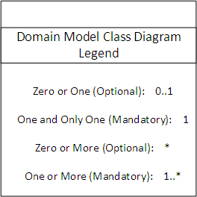

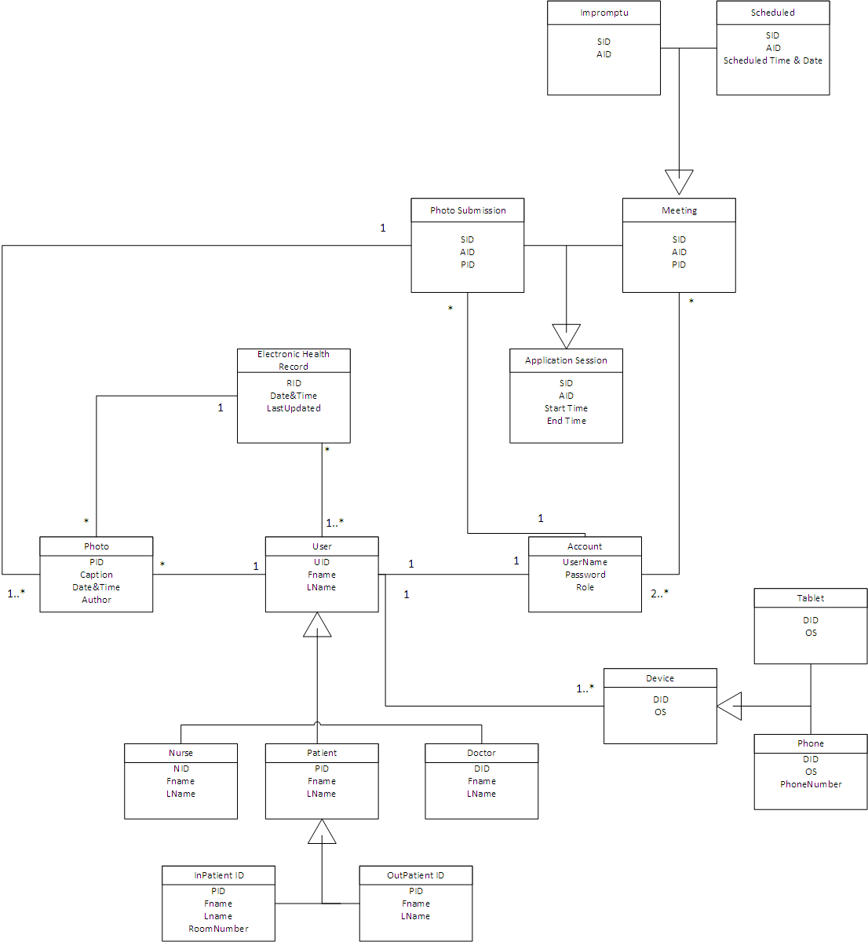

## State Machine Diagram

Upon reviewing the Domain Model Class Diagram, it was determined that the class “user” had the most complex set of transitions, because of how crucial the process is for the subclasses which are: 1) Patient (inpatient & outpatient), 2) Nurse, 3) Doctor.

The application has seven states. It first starts with the user (which could be any of the 3 mentioned above. It then splits into two transition paths, the application is either on the on or off state. If off, no further tasks are conducted and the application shuts down. When the application is on the on state, there are concurrent states of capture or idle. When the application is on the idle state, it is because the user has not proceeded in using the application, and after 15 seconds the inactive timeout (AppInactiveTrigger) is triggered, the application will proceed to the off state.

As for the capture state, the user will first take an image using their mobile app. Examples of possibilities include: a prescription, written documents in a patient’s chart, patient’s notes and requests, and handwritten doctor’s notes. The application then uploads the image into the SAP database as unstructured data. SAP then proceeds in converting the raw unstructured data into structured data. After this entire process, the conversion is completed, and the newly converted data can now be view and edited by the right user with the right access, which will be a document such as an electronical form with all the contents the user captured when it was unstructured data.

|  |  |
| --- | --- |
| **State** | **Transition causing exit** |
| On | *CaptureImage or AppInactive* |
| Off | *AppOff* |
| Idle | *AppInactiveTrigger* |
| Capture | *UnstructuredDataCapture* |
| Uploaded to SAP | *UnstructuredDataUpload* |
| SAP Conversion | *OutputStructuredRecord* |
| Conversion Complete | *AppOff* |

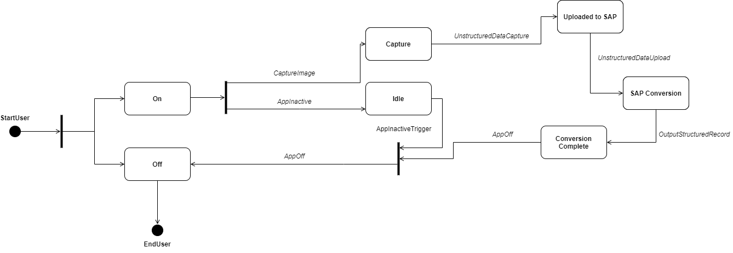

Figure: State Machine Diagram – Created on draw.io

## Fully Developed Use Case Descriptions

**Table 1:**

|  |  |  |
| --- | --- | --- |
| **Use Case Name:** | Schedule a Meeting | |
| **Scenario** | Patient wants to schedule a meeting. | |
| **Triggering event** | Patient believes a meeting is necessary. | |
| **Brief description** | Medical Inquiry (Sudden Illness, General Health Questions and Routines) | |
| **Actor** | Patient | |
| **Related use cases:** | Delete Meeting | |
| **Stakeholders** | Doctor, Patient | |
| **Preconditions** | Patient has an Account. | |
| **Postconditions** | Meeting is scheduled. | |
| **Flow of activities** | **Actor** | **System** |
|  | 1 Patient will press on the Schedule Meeting Icon.    2 Patient will select the appointment type.    3. Select the preferred Doctor.  4. Select the preferred Date and Time.  5. Patient presses the Confirm Icon | 1.1 System creates a prompt for an appointment.  2.1: System would confirm the appointment type.  3.1: System displays available doctors.    4.1: System displays Date and Time(s) available.  4.2: System displays Meeting Information (Appointment Type, Selected Doctor..)  5.2: System saves to the Database and updates the Database.  5.3: System sends a notification to the doctor. |
| **Exception Conditions:** | 1. The patient faces a scheduling conflict (Unavailable dates, Doctor not available, appointment cancellation). | |

**Table 2:**

|  |  |  |
| --- | --- | --- |
| **Use Case Name (2):** | Data Capture (Photo Capture) | |
| **Scenario** | The Nurse wants to capture data on the whiteboard. | |
| **Triggering event** | The Nurse sees vital information on the whiteboard. | |
| **Brief description** | The Nurse wants to upload the data from the whiteboard before it is removed. This data includes BMI, Prescription Information, etc. | |
| **Actors** | Nurse | |
| **Related use cases:** | The Nurse scans the RX cards. | |
| **Stakeholders** | Nurses, Doctors | |
| **Preconditions** | Patient information is written on the whiteboard. Nurse has an account created. | |
| **Postconditions** | The Unstructured Data is converted into Structured Data. Then the structured data is uploaded to SAP. | |
| **Flow of activities** | **Actors** | **System** |
|  | 1. Nurse will press on the Capture Icon.  2. Nurse will accept the Consent to using the Mobile Capture.  3. Nurse will position the camera to the Display Grid and capture image.  4. Nurse will press the Confirmation button for the verified data. | 1.1: System will prompt the user for Capture permission.  2.1: System will receive the confirmation of the consent.  2.2.: System will open the camera.  2.3: System will prompt the nurse to position to the correct information by the Display Grid.  3.1: The system will save a photo along with the metadata (Date, Time, User…)  3.2: System converts the Unstructured Data to Structured Data.  3.3: System will prompt the user to verify the data.  4.1: System will transfer the structured data to the SAP database. |
| **Exception Conditions:** | 1. Camera Malfunction.  2. Poor lighting.  3. Whiteboard handwriting not clear enough for the application. | |

## Activity Diagram

The Activity Diagram was needed to show an illustration of one of our Use Case Descriptions. By looking at Table 1 and Table 2 under “Fully Developed Use Case Descriptions,” the Flow of Activities for the Actors/System are what needed to make an Activity Diagram. The Exception Conditions are not included for the diagram. The process begins when the Patient presses “Schedule Meeting” for the system to create a prompt. After selecting the specific appointment, the system confirms it. Next, the patient selects a Doctor which will allow the system to display the available doctors. After that, the patient will select the appropriate date and time which will also allow the system to display what is available. When the meeting is confirmed, the system will finally update the database and send a notification to the Doctor chosen.

Figure:

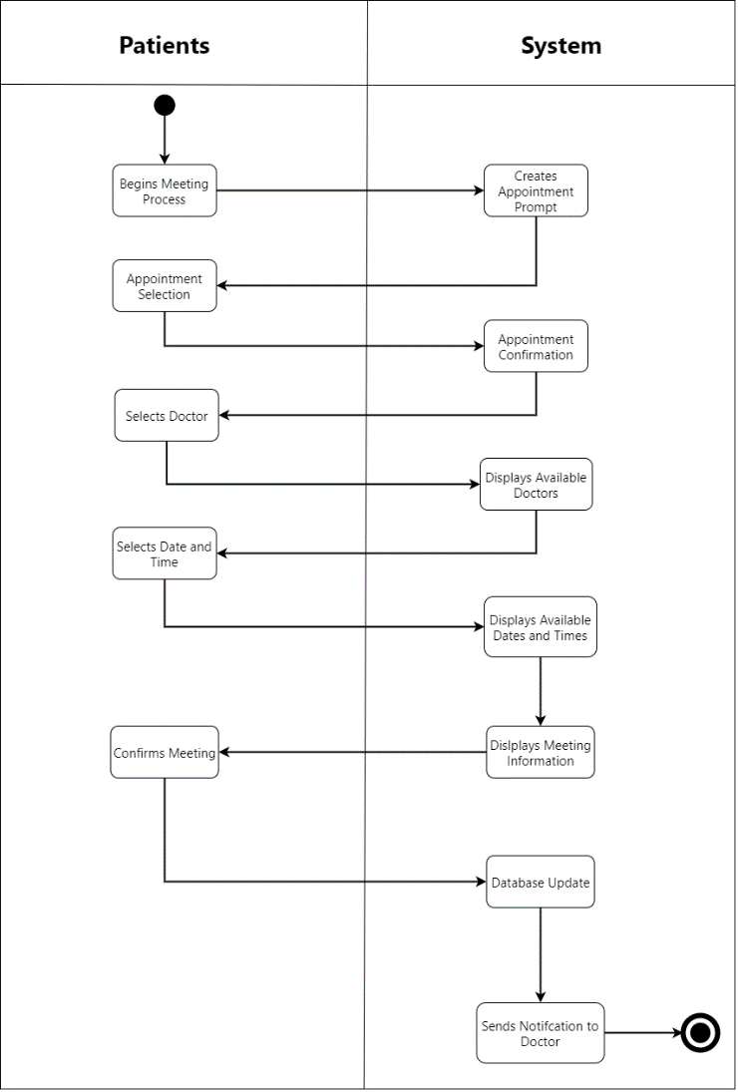

Created on draw.io

## System Sequence Diagram (SSD)

The System Sequence Diagram shown below is a detailed representation of our Activity Diagram. What makes it detailed in this diagram is to understand what the “input messages” are for the processes. The diagram begins when the patient creates an appointment just like the previous diagram above. The name, contact, and reason for the appointment are the input messages that end up being recorded in the system. For doctorSelection, name and specialty are selected for the system. The next process has the date and time saved to the system. The dotted lifelines are the results of the process that go back to the patient. The dotted lifelines are needed for the patient to see messages on the app that result the verifications and the meeting confirmation.

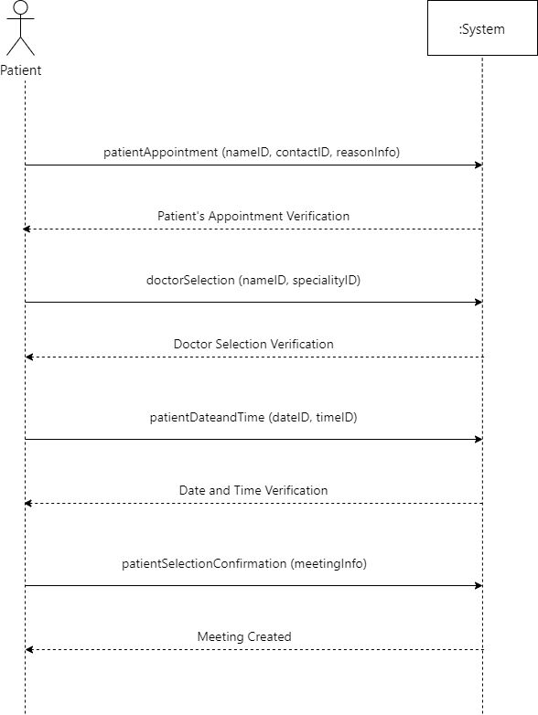

Created on draw.io

## CRUD (Bonus)

CRUD technique, which involves verifying that all of the needed use cases have been identified to maintain the data represented by the domain model class diagram. CRUD is an acronym for Create, Read or Report, Update, and Delete.

The CRUD technique for validating and refining use cases includes these steps:

1.Identify all the domain classes involved in the new system. Chapter 4 discussed these in more detail.

2.For each type of data (domain class), verify that a use case has been identified that creates a new instance, updates existing instances, reads or reports values of instances, and deletes (or archives) an instance.

3.If a needed use case has been overlooked, add a new use case and then identify the stakeholders.

4.With integrated applications, make sure it is clear which application is responsible for adding and maintaining the data and which system merely uses the data.

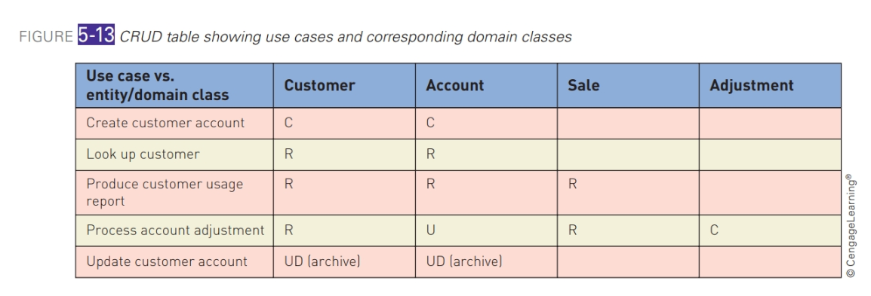

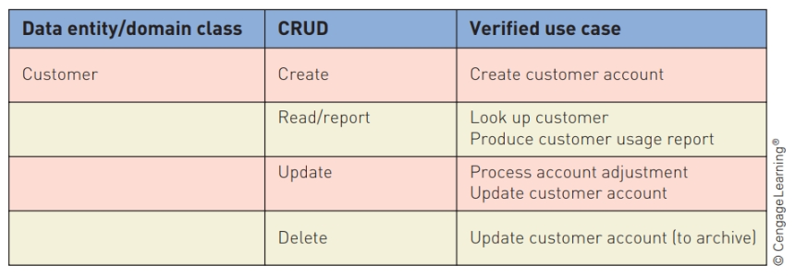

## Design Class Diagram (DCD)

The Design Class Diagram consists of two controllers: 1) Patient Handler 2) Meeting Handler. Both are objects in which perform actions to generate a meeting ID. To elaborate, the patient handler (which is the patient creating a meeting) will create patient account to setup meetings. Information for the patient such as name, DOB, contact and billing info will be entered, and login info (username and password) is provided. Additionally, both input messages are visible to the patient. What is not visible to the patient are attributes of the patient that are patient ID, name, DOB, billing info, and status, which run in the system's database. The patient class links to both controllers and the meeting class.

The meeting handler receives input from the patient that is specific to the meeting being requested. The patient will input the following attributes: Add meeting reason (urgency level), Doctor preference and specialty, and preferred date and time. None are visible to the patient. After that, the actual meeting ID and corresponding needs for the patient is generated within the meeting class - meeting ID, patient ID, Doctor ID, and date and time (not visible). As for the doctor class, the system will cross check and determine the doctor's availability based on the patient's needs. The attributes include Doctor ID, name, and specialty. If the doctor is available, the meeting is confirmed for the patient.

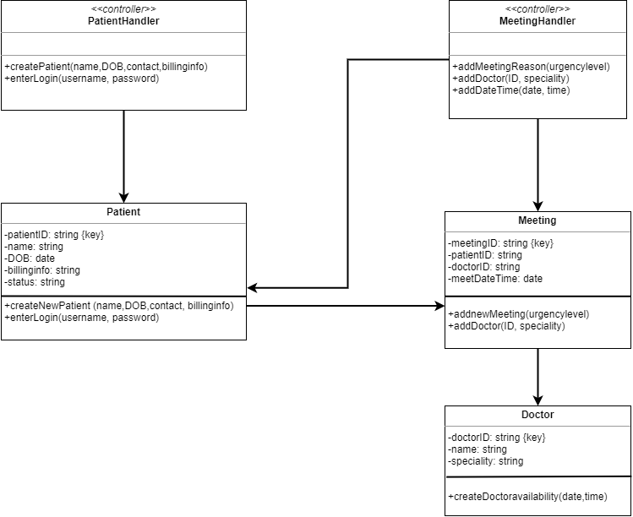

Created on draw.io

## Sequence Diagram with View and Data Access Layer

The Sequence Diagram that contains the View and Data Access Layers expands the System Sequence Diagram furthermore. When designing this specific diagram, you take each input message and establish all the internal messages that result from that input. Then you analyze the complete set of classes that will be affected by the message. The Design Class Diagram is also a good reference to include the messages from there to this diagram. The Controller class is responsible to catch the messages from the boundary class objects and send them to the correct entity class objects. MeetingHandler is created to send the messages to aMet:Meeting and aDS:Doctor. The Data Access class is used to retrieve data from and send data to a database. There are two boxes that represent the Data Access Layers. The box, :MeetingDA, is responsible to have the information of the saved meetings in the database. The box, :DoctorDA, saves the notification for the Doctor to have access after the meeting is confirmed. Then there are three boxes for the View Layers. The View classes are the visual objects of what the patient sees when using the app.

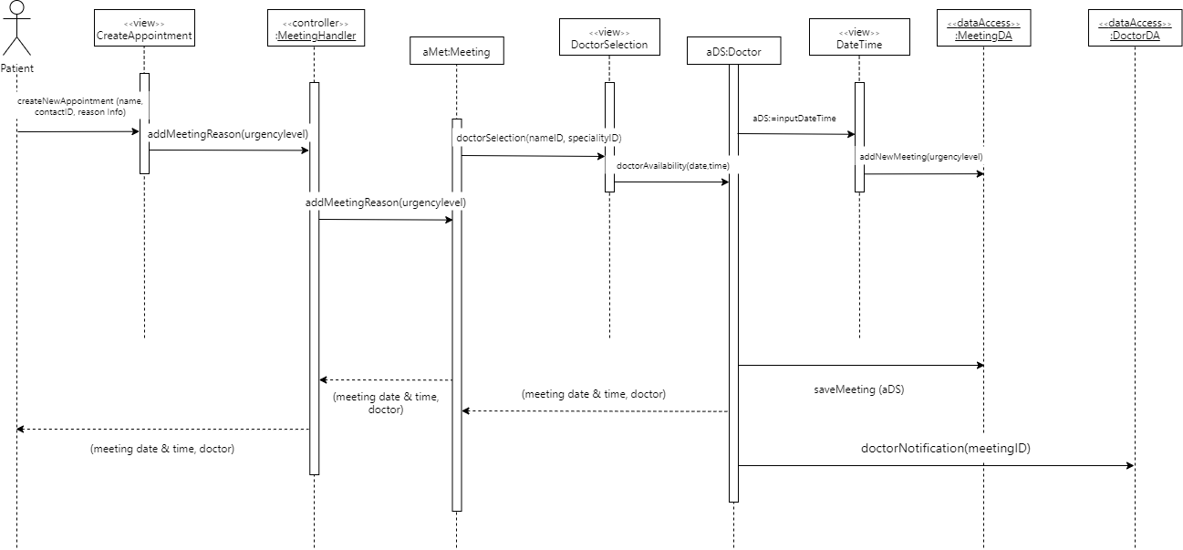

Created on draw.io

## Package Diagram

This package diagram consists of three layers: View, Domain, Data Access. The View layer consists of three components: “CreateAppointment,” “DoctorSelection,” and “DateTime.” It must be noted that the view layer represents the display that user will see. Thus, three components are the screens that user will interface with while setting up an appointment. The domain layer consists of “PatientHandler,” “MeetingHandler,” “Patient,” “Doctor,” and “Meeting.” This layer consists of the entities that enable our project. The main entities are patient, doctor, and meeting which are the major components of setting up the meeting. The handlers are used to resolve the request of the meeting and patients. The data access layer consists of “MeetingDA,” and “DoctorDA.” This layer focused on the entities that need their data access. The “CreateAppointment” connects to Meeting because a meeting is created when the user is on the “CreateAppointment” view. The “CreateAppointment” also connects to “MeetingHadler” to handle the creation of meeting. The “DoctorSelection” connects to patient because the patient needs to select a doctor. The DateTime connects to patient because the patient needs to select the time of the meeting.

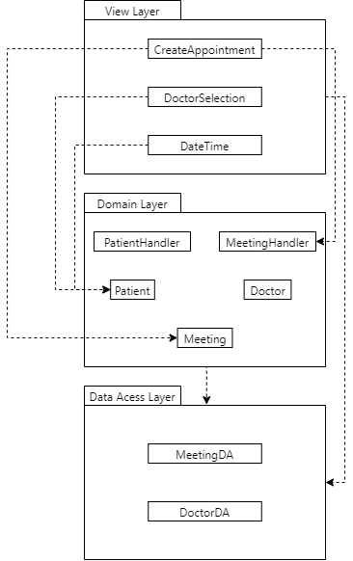

Created on draw.io

### Conclusion

A conclusion that summarizes the report and identifies areas for further development of the project. This should not exceed one page

### References

A reference section provides references to all information sources that have been studied/consulted and/or relied upon by your team to develop your project. This will include full references to the websites, books, articles from magazines, journals, newspapers, periodicals, etc., and the individuals you may have consulted and/or interviewed for your project. The citations should follow a standard style (such as the APA style). There is no page limit on the reference list.